
FIG RG IT "ZHULDYZ-CUP"
ASTANA, (KAZ)
June 04-06, 2015

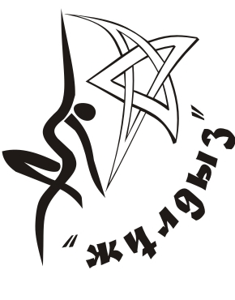

Form to be sent to:
Host Federation | Organizing Committee
Gymnastics Federation of Kazakhstan  Contact person:  Secretary General: Aigul Baekenova  48/1 prospectus Abai, Almaty, Kazakhstan  Phone : +7 (727) 292-37-57  Fax : +7 (727) 292-37-57  e-mail: gymnastic.kz@mail.ru | Astana, Kazakhstan, CRG "ZHULDYZ"  Contact person: Yelena Kunts  tel.: +7 (7172) 57 28 06;  +7 701 873 74 44;  +7 701 505 00 11  e-mail: shkola-zhuldyz@mail.ru  Yelena Kunts elena.kunc@bk.ru
Deadline: 05/05/2015
MEALS Form

Federation |  | Contact person:
Federation |  | Phone:
Federation |  | E-mail:

Date | Meal | Number (at xxx/person)
02.06.2015 | Breakfast
02.06.2015 | Lunch
02.06.2015 | Dinner
03.06.2015 | Breakfast
03.06.2015 | Lunch
03.06.2015 | Dinner
04.06.2015 | Breakfast
04.06.2015 | Lunch
04.06.2015 | Dinner
05.06.2015 | Breakfast
05.06.2015 | Lunch
05.06.2015 | Dinner
06.06.2015 | Breakfast
06.06.2015 | Lunch
06.06.2015 | Dinner
07.06.2015 | Breakfast
07.06.2015 | Lunch
07.06.2015 | Dinner
Banquet (complete if applicable) | Number:
 | TOTAL

Place and date | Seal of the NF | NF authorised signature
 |  | Signature of the President or Secretary General of the participating FIG affiliated NF

